Packet Tracer – Troubleshooting GRE

1. Topology

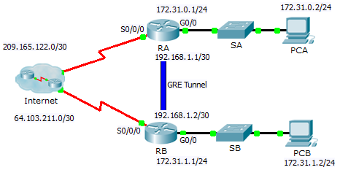

1. Addressing Table

|  |  |  |  |  |
| --- | --- | --- | --- | --- |
| Device | Interface | IP Address | Subnet Mask | Default Gateway |
| RA | G0/0 | 172.31.0.1 | 255.255.255.0 | N/A |
|  | S0/0/0 | 209.165.122.2 | 255.255.255.252 | N/A |
|  | Tunnel 0 | 192.168.1.1 | 255.255.255.252 | N/A |
| RB | G0/0 | 172.31.1.1 | 255.255.255.0 | N/A |
|  | S0/0/0 | 64.103.211.2 | 255.255.255.252 | N/A |
|  | Tunnel 0 | 192.168.1.2 | 255.255.255.252 | N/A |
| PC-A | NIC | 172.31.0.2 | 255.255.255.0 | 172.31.0.1 |
| PC-C | NIC | 172.31.1.2 | 255.255.255.0 | 172.31.1.1 |

1. Objectives

* Find and Correct All Network Errors
* Verify Connectivity

1. Scenario

A junior network administrator was hired to set up a GRE tunnel between two sites and was unable to complete the task. You have been asked to correct configuration errors in the company network.

1. Find and Correct All Network Errors.

|  |  |  |
| --- | --- | --- |
| Device | Error | Correction |
|  |  |  |
|  |  |  |
|  |  |  |
|  |  |  |
|  |  |  |

1. Verify Connectivity
   1. Ping PCA from PCB.

Attempt to ping the IP address of **PCA** from **PCB**. The ping should be successful.

* 1. Trace the path from PCA to PCB.

Attempt to trace the path from **PCA** to **PCB**. Note the lack of public IP addresses in the output.